**Code for Chapter 7**

**Example 7.5**

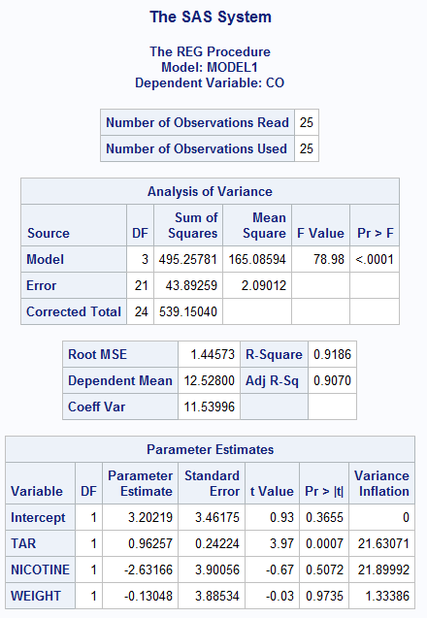

Correlation matrix for x’s

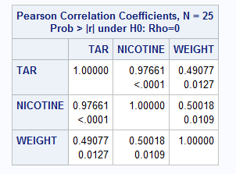

**data** ftccigar;

set 'H:\stat2223\my own\SAS\SAS\Exercises&Examples\FTCCIGAR.sas7bdat';

**run**;

**proc** **print** data=ftccigar;

**run**;

**proc** **reg** data=ftccigar;

model CO=tar nicotine weight/vif;/*show vif by parameter estimation output*/

**run**;

/*correlation matrix for 3 predictors(x)*/

**proc** **corr** data=ftccigar;

var tar nicotine weight;

**run**;

**Example 7.8**

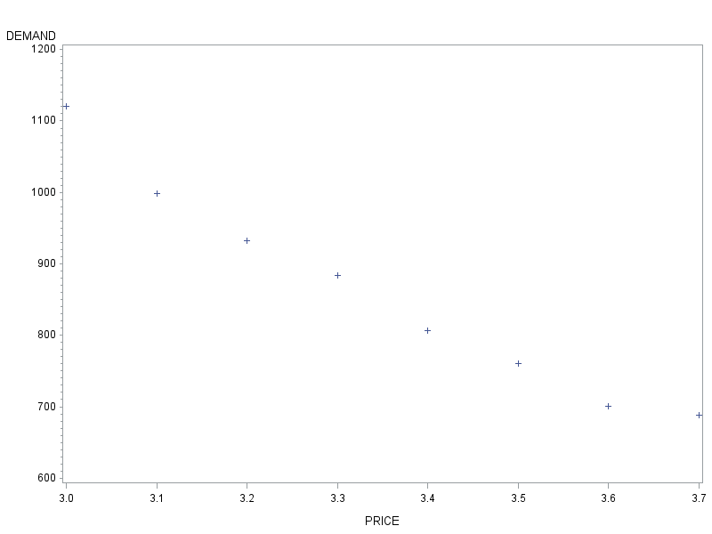

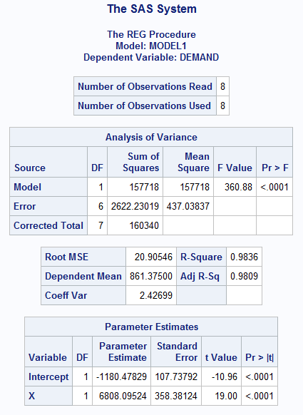

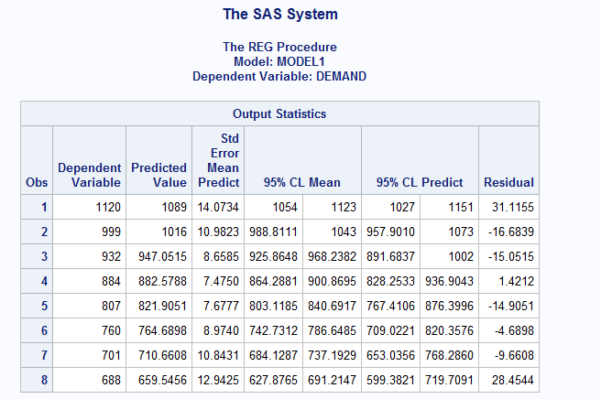

**data** coffee;

set 'H:\stat2223\my own\SAS\SAS\Exercises&Examples\coffee.sas7bdat';

**run**;

**proc** **print** data=coffee;

**run**;

**proc** **gplot** data=coffee;

plot demand*price;

**run**;

**proc** **reg** data=coffee;

model demand=x/clm cli;

**run**;